**Research Projects**

1. **Fundamentals of Multi-hop Multi-flow Wireless Networks**

Multi-hop Multi-flow communication paradigms are expected to play an important role in allowing a better reuse of the wireless spectrum. However, little is known about the fundamental principles that govern the design of communication schemes for such systems, and, in most of these scenarios, an exact characterization of the Shannon capacity is out of the question. We seek alternative approaches such as formulating and studying deterministic models that mimic the behavior of their stochastic counterparts, and considering the high-SNR approximation provided by a *Degrees of Freedom* analysis.

The characterization of the degrees of freedom often leads to a conceptual understanding of fundamental aspects of communication in these networks. This is the case, for instance, of the results in [3]. By showing that K degrees of freedom can be achieved on a two-hop K x K x K network, we provide an answer to a distributed MIMO problem which can be formulated in an algebraic way as a diagonalization problem. As illustrated below, if the K relays could cooperate (i.e., if they were a single MIMO node), they would apply the linear transformation ??, in order to diagoanalize the end-to-end network transform. But if the K relays cannot cooperate, how can this end-to-end diagonalization be obtained in a distributed way?



**Papers:**

"Two-Unicast Wireless Networks: Characterizing the Degrees of Freedom"

"On the Role of Deterministic Models in K x K x K Wireless Networks"

"Degrees of Freedom of Two-Hop Wireless Networks: “Everyone Gets the Entire Cake”"

1. **Robustness of Theoretical Models**

Gaussian models are ubiquitous in data compression and data communication problems. The additive noise experienced by wireless receivers, for instance, is often modeled as a white Gaussian random process. Similarly, but perhaps less intuitively, data sources are also commonly modeled as Gaussian processes. While these models are formally justified in point-to-point setups as the worst-case assumptions, the same was not known to be the case in network setups, and the main reason for these assumptions was analytical tractability. From a theoretical standpoint, a relevant question is: In what scenarios are these Gaussian models worst-case assumptions? And, from a practical perspective, how can compression and communication schemes designed under Gaussian assumptions be useful in non-Gaussian scenarios?

We answered these questions in the context of data communication in wireless networks [J2] and joint source-channel coding in arbitrary networks [J5]. We proved that the Gaussian distribution is indeed worst-case in these cases, by providing a framework that allows coding schemes designed under Gaussian assumptions to be converted to coding schemes that achieve the same performance under arbitrary statistical assumptions. The figure below illustrates this conversion for network compression problems.

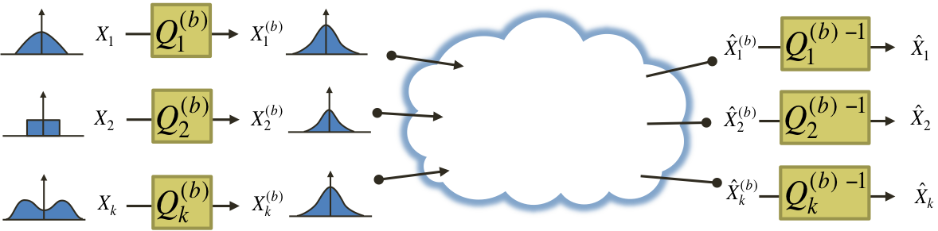

Each source node applies a transformation to its non-Gaussian data source with the purpose of “gaussifying” it. More precisely, we find a sequence of such transformations such that the resulting effective sources converge in distribution to Gaussian, i.e.,

.

We then show that there exist optimal coding schemes for this network for which the above convergence in distribution implies convergence in distortion, i.e.,

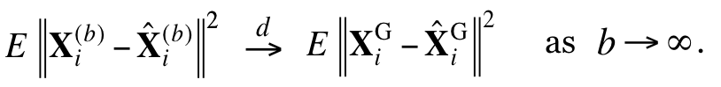

Besides settling the aforementioned questions, these results allow us to establish connections between the capacity (or distortion) regions of networks under different models. In [17], we pursued this direction and demonstrated that in two-hop multi-flow wireless networks the capacity under the Gaussian model can be upper bounded by the capacity of the network under a deterministic model.

**Papers:**

"Worst-Case Additive Noise in Wireless Networks"

"Network Compression: Worst-Case Analysis"

1. **Relay Networks with Practical Constraints**

The study of wireless systems is traditionally performed with simplified models whose goal is to capture the fundamental aspects of communication and provide insights into the design of optimal communication strategies. However, particularly for the case of large wireless relay networks, there are big discrepancies between these theoretical models and the practical systems, which makes the conversion from theory to practice a research effort in itself. Examples of these discrepancies include full duplex versus half duplex antennas, and the assumption of availability of channel state information at the network nodes.

The issues of synchronization between network nodes and energy-efficient communication, for instance, were addressed in [J3] in the context of a two-relay network. The main motivation for this work are wireless sensor networks, where nodes operate on batteries and the communication of data tends to be bursty, i.e., intermittent. In this scenario, synchronization techniques must be used before every data transmission, and the synchronization costs become relevant. In [J3], by approximately characterizing the minimum energy-per-bit required in this asynchronous scenario, we were able to prove the near optimality of training sequences for synchronization, and determine, for a given two-node network, what is the optimal relay selection, as illustrated below.

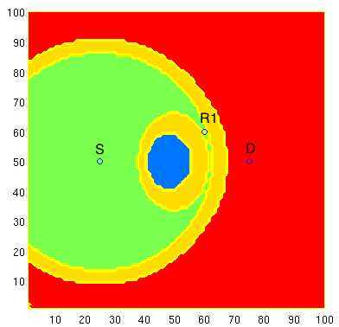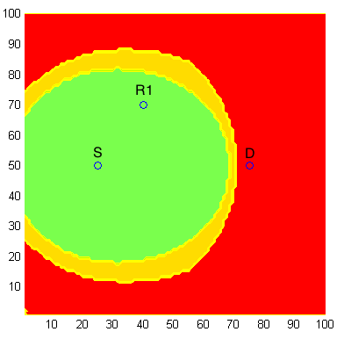

In the figures above, if relay R2 were in a green area, the optimal relay selection would be R1 and R2, if it were in a red area, the optimal relay selection would be R1, and if it were in a blue area, the optimal relay selection would be R2.

This research project comprises many of our ongoing and future research directions. In particular, we have been studying how results on degrees of freedom such as [J1] and [J6] are affected by real-world constraints such as computational complexity and limited channel diversity. For example, the recent work in [Issa] tackles these two issues by characterizing the degrees of freedom achievable with linear schemes and no channel diversity. We are currently studying how these ideas can be scaled for the general K x K x K setting.

**Papers:**

"Diamond Networks with Bursty Traffic: Bounds on the Minimum Energy-Per-Bit"

"On Min-Cut Algorithms for Half-Duplex Relay Networks"